­

LOYALSOCK TOWNSHIP

SCHOOL DISTRICT

GRADUATION PROJECT

A GUIDE TO COLLEGE & CAREER READINESS

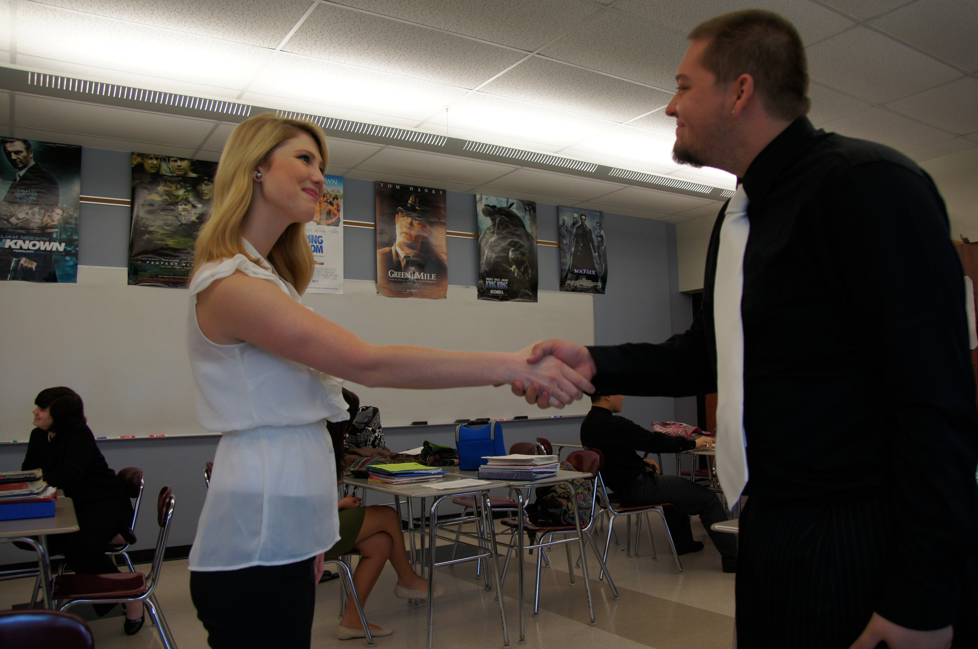

Place Photo Here,

Otherwise Delete Box

Dear Parents/Guardians and Students:

In accordance with Pennsylvania graduation requirements, all students must complete a mandatory Graduation Project. At Loyalsock Township High School, students complete a career-based Graduation Project over a three-year period which is designed to assist students in making informed career choices after high school.

During sophomore English class, students complete the Bridges.com online interest and skills assessment with Mrs. Herman, our career counselor. The assessment results are examined and students determine possible job shadow focus areas. Students have the option to complete at least one job shadow over the summer and/or choose to shadow during the junior year.

During junior English class, students complete the I-Search process, which includes an examination of several required components:   
(a) Bridges.com online Career Finder Assessment Results (b) Military ASVAB Skills and Interest Assessment (c) Job Shadowing experience (d) Examination of additional guidance and career-based internet resources (e) The Student’s Career Plan.

Ultimately, students will reflect on their individual strengths and weaknesses before compiling that information in to a 5-7 page research paper that articulates their post-secondary education or work plans. Each student will be required to present his/her career plans to a group of his/her peers in a 3-5 minute oral presentation at the conclusion of the I-Search process.

During Senior English class students complete an extensive job seeking skills unit that includes Resume Writing, Cover Letters, Interviewing Skills Preparation and a Senior Mock Interview. In addition to LTHS staff, outside professionals are utilized to authenticate the process.

Should you have any questions about this process, feel free to contact the high school English Department, School Counseling Team or Mrs. Herman, our Director of Student Services & Career Development. Emails are below:

Brooke Beiter: [bbeiter@loyalsocklancers.org](mailto:bbeiter@loyalsocklancers.org)

Chris Herman: [cherman@loyalsocklancers.org](mailto:cherman@loyalsocklancers.org)

Kelly June: [kjune@loyalsocklancers.org](mailto:kjune@loyalsocklancers.org)

Monica McCarty: [mmccarty@loyalsocklancers.org](mailto:mmccarty@loyalsocklancers.org)

Joe Smith: [jsmith@loyalsocklancers.org](mailto:jsmith@loyalsocklancers.org)

Diane Stanzione: [dstanzio@loyalsocklancers.org](mailto:dstanzio@loyalsocklancers.org)

Dana Williams: [dwilliams@loyalsocklancers.org](mailto:dwilliams@loyalsocklancers.org)

A Brief Overview

Project Timeline

**10th Grade: (Graduation Project Overview/Career Assessment/Job Shadowing Component)**

* Graduation Project Introduction
* Job Shadowing Overview  **~** Summer 2013 Job Shadowing Opportunity (optional)
* Required In-class writing assignment regarding career assessment results
  + Career Assessment – Bridges.com Interest Assessment [www.bridges.com](http://www.bridges.com)

**11th Grade: (I-Search Project)**

**Juniors with English during the Fall Semester will follow this timeline:**

* ***September*:** Graduation Project Overview with Mrs. Herman
* ***September – December*:** Complete a Job Shadow
  + Students/families are encouraged to find his/her own job shadow placement, but may contact Mrs. Herman for assistance.
* **September:** All juniors must take the ASVAB Assessment
* **October:** ASVAB Career Results - School Counselors
* **Required Writing Assignments**:
  + - 1-2 page Job Shadow Summary/Analysis   
      (unexcused absence if not submitted)
    - In-class writing assignment highlighting ASVAB results   
      (writing grade)
    - 5-7 page “I-Search” defines career plan

***********************************************************************************************************

**Juniors with English during the Spring Semester will follow this timeline:**

* **January:** Graduation Project Overview with Mrs. Herman
* ***January– May*:** Complete a Job Shadow
  + Students/families are encouraged to find his/her own job shadow placement, but may contact Mrs. Herman for assistance.
* **September:** All juniors took the ASVAB Assessment
* **February:** ASVAB Career Results - School Counselors
* **Required Writing Assignments**:
  + - 1-2 page Job Shadow Summary/Analysis   
      (unexcused absence if not submitted)
    - In-class writing assignment highlighting ASVAB results   
      (writing grade)
    - 5-7 page “I-Search” defines career plan

**12th Grade: (Resume Writing & Interviewing Skills Unit)**

* Completed during Senior English course:
  + *Resume Writing & Interviewing Skills Unit* –
    - 3-week Process – Start to Finish
    - How To Write A Perfect Resume
    - How To Write A Cover Letter
    - Interviewing Skills Prep
    - Senior Mock Interview

Place logo

or logotype here,

otherwise

delete this.

Delete text and place photo here.

Delete text and place photo here.

company

name

|  |  |  |  |  |  |  |
| --- | --- | --- | --- | --- | --- | --- |
| **S** | **M** | **T** | **W** | **T** | **F** | **S** |
| 1 | 2 | 3 | 4 | 5 | 6 | 7 |
| 8 | 9 | 10 | 11 | 12 | 13 | 14 |
| 15 | 16 | 17 | 18 | 19 | 20 | 21 |
| 22 | 23 | 24 | 25 | 26 | 27 | 28 |
| 29 | 30 |  |  |  |  |  |
|  |  |  |  |  |  |  |

**2008**

**june**



The I-Search Paper

Junior Year English

**PAPER FORMAT & STRUCTURE:**

A 5- to 7-page “I-Search” paper on a career area (or areas) of your choice   
**(20% of third marking period grade)**

The student is to reflect on what s/he has learned about himself or herself and about career choices and goals:

You may organize your paper in any way you like, as long as it’s logical and makes sense. *Here is a suggested outline:*

1. Introduction

II. ASVAB results

III. On-line inventory results

IV. Your career choice in reflection of the results from II and III

*What are some good career matches for you?*

*What would NOT be good matches for you? (i.e., What did you rule out?)*

V. Summary of job shadow experience   
 *What did you do? What did you learn?*

VI. Post-high-school requirements for this field

*What steps must now be taken to move toward a career?*

*What kinds of college goals or work experience will be necessary?*

VII. Employment opportunities on a local, state and/or national level

*What are employment opportunities and prospects including salary?*

VIII. Your current plans for the future  
 *What post-secondary education or skills training do you plan to pursue?*

IX. Conclusion

*What did you learn from this process? What do you still question?*

## **WORKS CITED SOURCES:**

TWO PRIMARY SOURCES: FIVE SECONDARY SOURCES:

## 1. Job Shadow 1. ASVAB Assessment Results

2. Interview and/or Experience 2. Bridges Career Assessment Results

-- interview a second person at the job shadow 3. PA Career Zone Website

-- use work or volunteer experience 4. Education Planner Website

-- attend the Career Expo or College Night 5. US Department of Labor Statistics Website



***Useful Websites for Career Exploration and Planning***

**Bridges.com**

**Web address:** [**http://www.access.bridges.com**](http://www.access.bridges.com) **Sit ID: 0047349**

**Password: administrator**

**Career Zone – Pennsylvania  
Web address:** [**http://pacareerzone.org**](http://pacareerzone.org)

**Education Planner**

**Web address:** [**http://www.educationplanner.com**](http://www.educationplanner.com)



## ***Sample Works Cited Page***

“Assess Yourself.” Career Zone – Pennsylvana. 2013.

Your date of access <http://pacareerzone.org>.

“Career Finder.” Choices Explorer. 2013. Bridges Transitions, Inc.

*Date of access* <https://cxonline.bridges.com-/cx/careers/finder/Introduction.do>.

“Psychologist.” Occupational Outlook Handbook.

*Date of document*. Online. *Date of access* <http://www.bls.gov/oco/>.

Richards, Thomas. Job Shadow. *Date.*

Stratton, Deborah. Personal Interview. *Date.*

United States Department of Defense. Exploring Careers.

Chicago: GPO, 2013.

United States Department of Labor Statistics. Occupational

Outlook Handbook. Current ed. Indianapolis: Jist, *year*.

FOR OTHER INTERNET SOURCES:

Author (if given). “Title of page.” Date of document or page.

Name of website. Name of sponsoring org (if given).

Your date of access <full url>.



***11th Grade I-Search Paper Scoring Rubric***

|  |  |  |  |  |  |  |
| --- | --- | --- | --- | --- | --- | --- |
|  | **Meets Expectations**  **35-29** | **Needs Improvement**  **28-20** | **Unsatisfactory**  **14-0** | | **SCORE** | |
| **CONTENT** | Excellent detailed discussion. All elements from checklist included in the body of the paper. | Too much regurgitation or filler content, without demonstration of student voice. | Essay lacks thorough discussion of the topics outlined on the checklist. | |  | |
| **TOTAL** |  |  |  | | **__ / 35** | |
|  |  |  |  | |  | |
|  | **Meets Expectations**  **20-16** | **Needs Improvement**  **15-11** | **Unsatisfactory**  **10-0** | | **SCORE** | |
| **In-text Citations and Works Cited Page** | Followed MLA format for in-text citations and works cited page. | Some errors in MLA format and in-text citation documentation. | Did not follow MLA format and has no in-text citations. | |  | |
| **Usage  (Spelling, Punctuation, & Grammar)** | No errors  or minimal errors which have not distracted the reader from the content. | A few spelling and grammatical mistakes which have distracted the reader. | Too many errors to be considered a final copy. | |  | |
| **TOTAL** |  |  |  | | **__ / 40** | |
|  |  |  |  | |  | |
|  | **Meets Expectations 15-13** | **Needs Improvement**  **12-9** | **Unsatisfactory 8-0** | | **SCORE** | |
| **Sources** | Meets all primary and secondary source requirements. | Fewer than the required number of primary and/or secondary sources. | Few or no primary and/or secondary sources. | |  | |
| **TOTAL** |  |  |  | | **__ / 15** | |
|  |  |  |  | |  | |
|  | **Meets Expectations**  **10-9** | **Needs Improvement 8-6** | **Unsatisfactory**  **5-0** | | **SCORE** | |
| **Structure** | Contains introduction, conclusion and transitions between and within paragraphs. | Few transitions.  Organization is not clear. | Few, if any transitions.  Missing introduction and/or conclusions. | |  | |
| **TOTAL** |  |  |  | | **__ /10** | |
|  |  |  |  | |  | |
| **PASS (80+) = 80%**  **FAIL**  **___ / 100** | Comments: |  |  |  | |



***Cover Letter Scoring Rubric***

|  |  |  |  |  |
| --- | --- | --- | --- | --- |
| **CONTENT** | **Competitive**  **3** | **Meets Expectations**  **2** | **Needs Improvement**  **1** | **SCORE** |
| **Length** | Has three paragraphs (middle paragraph is the longest), and fits on one page. | Good, but is somewhat short or a bit too long. | Extremely short or extremely long. |  |
| **Format - Block Business Letter** | No indentations, single spaced, and proper spacing between sections and paragraphs. | One or two errors with the block format. | Three or more errors with the block format. |  |
| **Fonts** | Used appropriately sized fonts that look professional and easy to read. | Font is easy to read, but may not be the best choice for a professional cover letter due to font style or size. | Font is hard to read or completely inappropriate for a cover letter. |  |
| **Date & Address** | Date is written out, return address is formatted professionally. | There are 1-2 problems with the formatting of names, address, or the date. | Three + problems exist with date and address formatting. |  |
| **Opening Paragraph** | States the job title you’re seeking, how you heard about it, and a compliment or connection. | Missing one of the required pieces of information. | Missing two+ pieces of required information. |  |
| **Middle Paragraph** | Longest paragraph- Provides examples of skills and experiences and relates them to the job posting. | Contains skills, but could have used more examples. | Did not clearly express what you can do for them. |  |
| **Closing Paragraph** | Thanked the reader and initiated the next step. Provided contact information | Missing one of the required pieces of information. | Missing two+ pieces of required information. |  |
| **Verbiage** | Powerful action verbs (not “was” and “did”) are used to make points and examples provided. | Few points lacked examples or could have been made more powerfully/professionally. | Lacks both examples and strong verbs to summarize accomplishments. |  |
| **Spelling and Grammar** | No spelling or grammar mistakes. | There is one minor spelling or grammar mistakes. | Two+ spelling or grammar mistakes. |  |
| **TOTAL** |  |  |  | **__ /30** |
|  |  |  |  |  |
| **PASS (24+) = 80%**  **INCOMPLETE**  **___ / 30** | Comments: |  |  |  |



|  |  |  |  |  |
| --- | --- | --- | --- | --- |
| **APPEARANCE** | **Competitive**  **5** | **Meets Expectations**  **4** | **Needs Improvement**  **3** | **SCORE** |
| **Layout & Format** | Consistent throughout the document | Minimally inconsistent  (a small margin or spacing error) | Inconsistent use of margins, spacing, bolding, italics, formatting, etc. |  |
| **First Impression/  Visual Appeal** | Exceptional, polished presentation | Acceptable | Unacceptable:  too wordy; does not use action statements |  |
| **Errors**  **(spelling & grammar)** | -- | No errors | One or more errors |  |
| **TOTAL** |  |  |  | **__ / 14** |
|  |  |  |  |  |
| **CONTENT** | **Competitive**  **10** | **Meets Expectations**  **9** | **Needs Improvement**  **8** | **SCORE** |
| **Header:**  **Identifying Information** | Follows guidelines specific to the header; Accurate and complete | Follows guidelines specific to the header; font style or size need adjusted | Does not follow specific guidelines; information is not accurate or complete |  |
| **Education/Skills** | Includes high school, job shadow, internship, and/or college coursework in specified format;  Highlights skills and relevant coursework sought by employers | Includes high school, job shadow, internship, and/or college coursework in specified format; does not include skills or relevant coursework sought by employers | Does not follow guidelines and/or missing key information;  Skills/relevant coursework not included |  |
| **Activities/Awards** | Leadership, awards, & accomplishments identified in top third of the resume | Participation, awards, & accomplishments identified | Participation or membership identified |  |
| **References** | References are realistic and relevant; includes complete and accurate contact information | References are realistic; Missing complete contact information | References are not relevant or realistic; Contact information is not included |  |
| **TOTAL** |  |  |  | **__ /40** |
|  |  |  |  |  |
| **PASS (43+) = 80%**  **INCOMPLETE**  **___ / 54** | Comments: |  |  |  |



***Resume Scoring Rubric***

|  |  |  |  |  |  |  |
| --- | --- | --- | --- | --- | --- | --- |
| **DRESS & APPEARANCE** | **Competitive**  **12-11** | **Meets Expectations**  **10-9** | **Needs Improvement**  **8** | | **SCORE** | |
| **Clothing** | Clothes are pressed and professionally appropriate. | Clothes are pressed, but not professionally appropriate. | Clothes are too casual. | |  | |
| **Grooming** | Hair, facial hair, teeth, and nails are all cleanly displayed. | Hair, facial hair, teeth, and/or nails are kempt, but lack professional appearance. | Hair, facial hair, teeth, and/or nails are dirty, disheveled, and unprofessional. | |  | |
| **Resume** | Neat, complete, and on professional paper. | Neat, complete, but on copier paper. | Neat, but incomplete. | |  | |
| **Handshake** | Firm | Weak | Not Attempted | |  | |
| **TOTAL** |  |  |  | | **__ / 48** | |
|  |  |  |  | |  | |
| **CONTENT** | **Competitive**  **18-17** | **Meets Expectations**  **16-15** | **Needs Improvement**  **14** | | **SCORE** | |
| **Poise and Voice** | Confident and enthusiastic; effective speech rate, volume, and inflection. | Relaxed and at ease during the interview; speech rate, volume, and inflection usually appropriate. | Self-conscious, nervous, shy; Low/loud volume. Monotonous tone.  Speech too fast/slow. | |  | |
| **Eye Contact** | Consistently makes direct eye contact with the interviewer. | Often makes eye contact with the interviewer. | Avoids eye contact with the interviewer/ make eye contact on occasion. | |  | |
| **Language and Delivery** | Uses appropriate vocabulary with mature and professional speech.  Avoids distracting mannerisms  (“likes,” “ums,” tapping, twisting, hair twirling). | Uses appropriate vocabulary, but speech may be a little too casual.  Use of an occasional distracting mannerism. | Vocabulary is inappropriate or too casual; use of slang.  Often use of distracting mannerisms. | |  | |
| **Skill Presentation** | Answers questions with examples. Demonstrates skills and qualities that are strongly beneficial to employer. | Answers questions with examples. Demonstrates some skills or qualities of interest. | Answers are quick and not detailed. Minimal skills are revealed to the employer. | |  | |
| **TOTAL** |  |  |  | | **__ /72** | |
|  |  |  |  | |  | |
| **PASS (96+) = 80%**  **FAIL**  **___ / 120** | Comments: |  |  |  | |



***Mock Interview Scoring Rubric***

Place logo

or logotype here,

otherwise

delete this.

Place logo

or logotype here,

otherwise

delete this.

Delete text and place photo here.

Delete text and place photo here.

company

name

|  |  |  |  |  |  |  |
| --- | --- | --- | --- | --- | --- | --- |
| **S** | **M** | **T** | **W** | **T** | **F** | **S** |
|  |  | 1 | 2 | 3 | 4 | 5 |
| 6 | 7 | 8 | 9 | 10 | 11 | 12 |
| 13 | 14 | 15 | 16 | 17 | 18 | 19 |
| 20 | 21 | 22 | 23 | 24 | 25 | 26 |
| 27 | 28 | 29 | 30 | 31 |  |  |
|  |  |  |  |  |  |  |

**2008**

**january**