Mrs. Remsnyder’s 8th Grade Health Expectations:

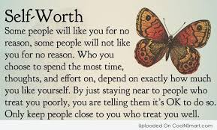

Course Description:

“It is the goal of Loyalsock Township Middle School to enhance the health status of our students and enable them to become responsible, healthy adults. Meaningful curricular activities and a blending of content will help to achieve this. Student will practice and master life skills such as decision-making, problem solving, goal setting, managing stress, practicing refusal skills and resolving conflicts. As these skills are developed, students will discover lifelong abilities that will guide them toward a healthy lifestyle.”

Topics to be discussed:

* Tobacco, Alcohol, and Drugs
* Body Systems
* Relationships
* Abstinence/ Sexually Transmitted Diseases
* Communicable/non-communicable Diseases

Grading:

You will earn a Health grade based on the following criteria:

Daily classroom points (20 points per day)

Unit Exams/Projects (50-100 points per exam/project)

Class Assignments/Homework (5-20 points/assignment)

Quizzes (10-30 points)

I will do my best to create a comfortable learning atmosphere due to the sensitive topics being discussed. If at any time you feel uncomfortable with a topic, please see me and we can arrange an alternate assignment. If you have any questions please feel free to contact me.

Mrs. Remsnyder

Email: [tremsnyder@loyalsocklancers.org](mailto:tremsnyder@loyalsocklancers.org)

Phone: (570) 323-9439 Ext. 1225



Student _______________________________________________

Parent/Guardian ______________________________________

Parent e-mail address __________________________________

E-mail: **Only** if you are okay with receiving e-mails about your child

Phone Number___________________________

