Quick Reference
Orienting the SMART Board Interactive Whiteboard  You should orient your interactive whiteboard when setting it up, or if either the projector or interactive whiteboard has been moved since you last used it.  - Press and hold the Keyboard and the Right Mouse button simultaneously until the Orientation screen appears.  - Begin the orientation process at the upper left corner of the Orientation screen.  - Press your finger or pen firmly on the center of each cross in the order indicated by the white, diamond-shaped graphic | 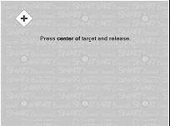  TIP: If someone accidentally takes a pen or the eraser home, simply cover the optical sensor with a pen lid or a sticky note to continue using your interactive whiteboard until the tool is returned.
Using Microsoft Office Applications with SMART Board  - Press to insert your drawing or writing as an image directly into your document  - Press to convert your writing as typed text directly into your document. Your text will appear at the cursor point or in the selected cell and in the color the words were written.  - Press to save a screen capture in Notebook software | 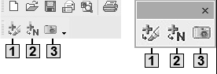
Move and reveal  - Type your question and answer  - Draw a rectangle and fill it with color to hide the answer  - Double-press the shape for the ability to add text to it – ensure your text is a different color than the rectangle  - Type Move the box to reveal the answer  - Move the shape to reveal the answer |     Before  After
Screen Shade reveal  - Type your question and answer  - Press the Screen Shade button on the Notebook software toolbar  - Drag the Screen Shade so only the answer to your question is covered  - When you are ready, drag the Screen Shade so it no longer covers the answer. | 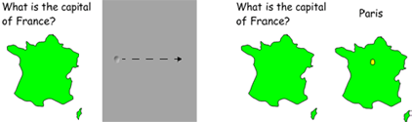  Before  After
Drag and drop  Drag and drop activities are an excellent way to determine if your class has achieved recognition about specific learning objectives.  - Add the object you want labeled to the work area.  - Use the object drop-down menu to lock the object that will be labeled in place. This action ensures the object won’t be accidentally moved during the lesson activity.  - Make the labels for your diagram and line them up at the bottom of the Notebook page. | 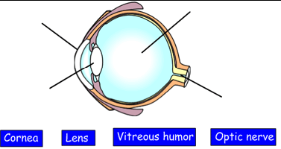
Infinite Cloner  The Infinite Cloner allows you to reproduce an object an unlimited number of times, without having to select clone repeatedly from the drop-down menu.  To set an object as an Infinite Cloner, complete the following steps:  - Select an object  - Press on the object drop-down menu  - Select Infinite Cloner  - Press on the object, then drag to create an identical object | 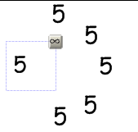
Using the Capture Toolbar  Use the Capture toolbar to capture a selected area of your screen.  - Open Notebook software  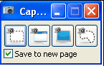  - Select View > Screen Capture Toolbar on the Notebook software menu to open the Capture toolbar  - Navigate to the screen you want to capture, such as a Web page.  - The captured image will appear on a page in your Notebook file | Capture a rectangular area of the screen  Capture the entire screen  Capture a particular window on the screen  Capture a freehand area on the screen

Notebook Software Toolbar

Button | Use this tool for | Button | Use this tool for | Button | Use this tool for
 | Display the previous Notebook page |  | Delete any selected object |  | Draw a line
 | Display the next Notebook page |  | Show/hide the Screen Shade on the current Notebook page |  | Create a shape
 | Insert a blank Notebook page directly after the active notebook page |  | Open Full Screen view |  | Create a text-entry box for typing
 | Open an existing Notebook file |  | Launch the Screen Capture toolbar |  | Set the color of a drawing tool or selected shape
 | Save your Notebook page |  | Select any object on the page with your finger or mouse |  | Set the transparency of a drawing tool, a selected shape or an object
 | Paste copied object(s) into a Notebook file |  | Write or draw on the Notebook page with the pen tool |  | Select the line properties of a drawing tool or selected shape
 | Undo the last action you performed |  | Write or draw on the Notebook page with the creative tool pen |  | Move the toolbar to the bottom of the Notebook page
 | Redo the last action you performed |  | Erase digital ink on the Notebook page

