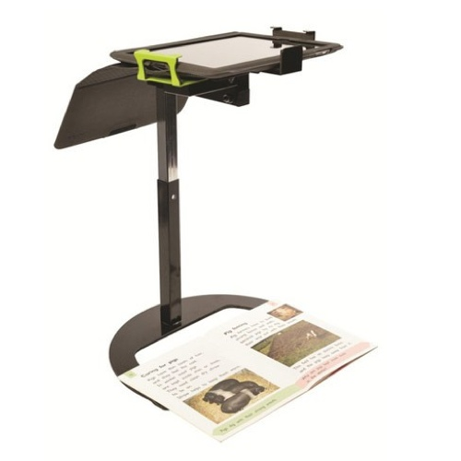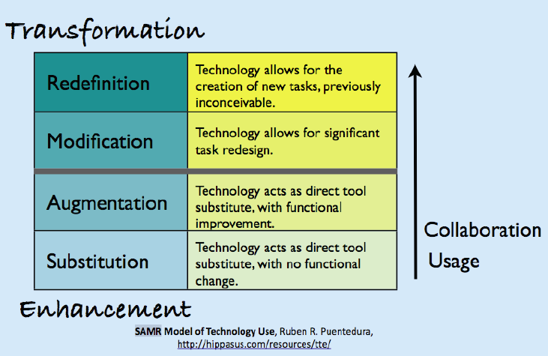

2014-2017 Technology Goals

**2014- 15**

**Technology Hardware Plan**

Purchase five, 30 station iPad sync carts and place three in Schick for general use while placing the remaining two in grades 6 and 7 for use in grade level classrooms.

**Software/App Plan**

Continue using Moodle as our Course Delivery software expanding it to include all HS courses for our students to experience a true hybrid learning experience.

Increase the use of NearPod in HS classrooms to increase student engagement by creating guided lessons, developing formative assessments during class, and generating meaningful feedback during lesson delivery.

Begin Development of lessons centered around the SAMR model fully utilizing the iPads and various apps that can be downloaded at little or no cost to the district. (See pg. 7) Our goal is to have every teacher create at least one M or R level lesson per marking period.

Projects completed this year

Having students create a walking map of a Central/South American city using Google Maps for a Spanish lesson is a great example of how teachers can Redefine student centered learning.

Continue using GoodNotes, Keynote, and other apps we have previously identified.

**Virtual Education**

We currently offer a full on-line/at home educational experience for Loyalsock students who want to continue enrollment in the district. My goal is to invite parents of children who live in the district but have elected to attend a cyber-charter school to an informational meeting concerning our virtual solution. There are many benefits for transitioning back to the district including graduating with a Loyalsock diploma and participation in our in-house elective offerings that these parents may not be aware.

**Software/App Plan**

Continue using Moodle as our Course Delivery software expanding it to include all MS/HS courses for our students to experience a full hybrid lesson. We will continue to build meaningful content in the software.

Increase use of NearPod by purchasing licenses for all teachers K-12 at a cost of $5,000

Begin a focus on the new Google applications such as Drive and Classroom as a fully inclusive experience for our students. Google drive is fully integrated into all apps used on the iPad a a storage medium. Google Classroom will allow uploading of content created on the iPad and uploaded into Drive. These applications are offered to public education institutions at no cost.

Teachers begin to create personalized coursework content for use in their classrooms using iBooks Author and the Macbook. The expectation will be for teachers to create one chapter of a course text book per semester using the software.

Continue transforming lessons into the MR levels of the SAMR model. The expectation will be that all teachers in grades 8-12 will build two lessons per marking period that reflect the MR level of the model.

Develop key grade level apps for all carts at Schick. These will be standardized and organized to support instruction in the classroom.

**2015-16**

**Technology Hardware Plan**

Purchase iPads for every 6th-7th grade student (275) and move the two carts purchased in 14-15 down to Schick giving them one mobile sync cart for each grade level. While we have had very few problems with 8th grade students taking the iPads home, to start the school year we feel it is in the best educational interest to assign an iPad to 6th grade students during the school day and have them initially remain in school on charging carts until we have prepared students to take them home on a full-time basis and allow the 7th grade students to take them home for full inclusion into the curriculum.

Begin phasing out Smartboards and projectors as units fail with HD 60” TV’s. This is made possible by applications on both PC and iPad that replicate the Smartboard device. A Smartboard/projector package cost is $2,500 per classroom while a 60” HD TV will cost $800 per classroom. We will begin to create learning spaces within classrooms that take advantage of the iPad capabilities by installing iPad stands that replace document cameras and overhead projectors. These stands cost $60 while a document camera costs $749. With many free apps such as the Show Me Interactive White board for the iPad that will provide the same interactivity while not reducing teacher efficiency.

Purchase 40 more Macbook Air laptops to replace Dell Laptops for teachers district-wide at a cost of $67,000. This will replace the normal technology line item of Dell replacement computers for these teachers.

We will also replace the 100 Dell laptops purchased through Title I grant funding at Schick with iPads. This will save the district $30,000. I have had a conversation with Mrs. Deitrick and will look at alternative ways that Title I funding could be used to cover some or all of this replacement.

**2016-2017**

**Technology Hardware Plan**

We will end our lease of the initial 640 iPads and lease 640 new model iPads for faculty and students in 8th-12th grade. We will reutilize those existing devices in our elementary school in both classrooms as stations and on carts as additional mobile labs.

Purchase 40 Macbooks ($67,000) for the remaining teachers in the district.

Begin phase out of three stationary computer labs in the HS/MS by rewriting course materials to include iPad based apps to fulfill all course requirements. This could potentially result in a cost savings of $120,000 to the district. We will keep two computer labs in the building for courses that use intense processing such as Digital Photography and Computer Aided Drafting.

Continue the transformation of classrooms into learning labs with iPad stands and TV’s as current units fail and where appropriate.

**Software/App Plan**

Begin the phase-in of Google classroom to house our hybrid course materials. This will be a multi-year phase in based on the number of courses we have built in Moodle. This will also incorporate Google Drive and the various other apps included with the Google platform. Our goal will be to provide professional development over the course of this year to transition to

Google as our content delivery system. Google Classroom is designed to help teachers create and collect assignments and the ability to automatically make a copy of a Google Document for each student, focusing on collaboration. It also creates Drive folders for each assignment and for each student to help keep everyone organized.

Students can keep track of what’s due on the Assignments page and begin working while teachers can quickly see who has or hasn't completed the work, and provide direct, real-time feedback and grades.

With Google’s focus on educational applications including unlimited storage space for all users, no cost

MS and HS teachers will continue adding chapters to their existing iBooks with a goal for those teachers who received their Macbook in 2014-15 of creating full e-text books for one course.

**Professional Development Goals**

Experience has shown the importance of creating school conditions that support and encourage teachers as they work to develop basic technology skills and integration strategies. We will continue providing in-school time for professional development, best practice sharing, curriculum planning, and provide a culture for teacher experimentation as well as before and after school time for voluntary collaboration and sharing sessions. Teachers will need easy access to iPad apps and devices that assist in the delivery of these instructional apps.

ISTE has developed the Elements of Effective Staff Development for the Technological Development of Teachers. A number of elements, we can implement to help define an effective staff development program for teachers focused around technological development. They include:

1. Provide sufficient learning time so teacher will learn to use technology effectively for personal and instructional uses.
2. Address individual teacher differences and supplement individual strengths, being sensitive to each teacher's expertise and experience.
3. Allow flexibility in programming and instructional learning opportunities.
4. Invest in individuals who are experienced in both technology and curriculum at either the school or district level.
5. Design instructional environments around collaborative problem solving and cooperative learning.
6. Provide training and related instruction that allows time for continued, ongoing learning, and support.
7. Avoid isolating technology as a separate discipline. Provide an instructional focus that illustrates how technology can support educational objectives.
8. Design instruction and activities that engage teachers both intellectually and professionally.
9. Develop school administrators who encourage the technological development of teachers.

**Network Plan**

We will have to increase the bandwidth coming into the district to handle the increase in internet capable devices over the course of this plan. This may happen without additional cost to the district as we have doubled the internet capacity every three years in the past 9 years keeping our cost per year the same. However, it will be a critical point of failure that we must be aware of as we continue to add devices. Our current wireless network was designed to handle this increase in capacity. With 900 devices this past year we peak at 80% capacity for a very short part of the day. On average we operate at 50%-60% of capacity on a daily basis.

**Estimated three-year budget**

|  |  |  |  |  |  |  |
| --- | --- | --- | --- | --- | --- | --- |
| **2014-15** |  | | **2015-16** |  | **2016-17** |  |
| 5 iPad Carts  30 iPads/cart | $124,700 | | 380 ipads –  6th and 7th grade students and Title I | $90,000/lease | 640 ipads –  refresh grades 8-12 | $150,000/lease |
|  |  | | Existing Final year lease payment | $185,000 |  |  |
|  |  | | Macbook Purchase vs. Dell Purchase | $31,000 | Macbook Purchase vs. Dell Purchase | $31,000 |
|  |  | | Purchase iPad management software allowing teachers to lock student iPads | $15,000 |  |  |
|  |  | | Purchase Nearpod licenses | $5,000 |  |  |
| Total | $124,700 | Total | | $326,000 | Total | $181,000 |

**SAMR Examples Using a Word Processing Assignment**

**Substitution -** Students use a word processor for their writing.  Students can now easily edit and format their

writing.  Published student work is now printed rather than handwritten. Students can save

various drafts of their work and can produce multiple copies of the finished product without

using a photocopier.

**Augmentation –**

Students improve their writing through utilizing the embedded tools in the word processor

such as the spelling and grammar check, and thesaurus.  Images, digital photographs and

graphics are now easily incorporated into the overall document design.  Students can choose

easily from multiple page layouts and alternate page designs to enhance their product.

**Modification** –

Teacher shifts the focus of some of the class writing assignments to be collaborative.  Students

utilize online wikis to write in small groups, conduct peer editing and feedback, and to comment on each group's final products.  Work on the projects can be done synchronously in class time,

as well as out of class.  The final writing projects are shared electronically with the wider

school community through the class website/blog.

**Redefinition -**

The class collaborates with other classes locally or globally on a common issue or problem.

Students research and share their findings in order to find a common solution.  The project has

grown to be cross-curricular and multidisciplinary, utilizing the strengths of the students in the

different classes.  Students use a variety of multimedia to collect, communicate and distribute

their findings and conclusions.  Various technologies are used to communicate and share

information between the various school groups.